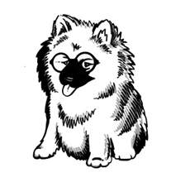
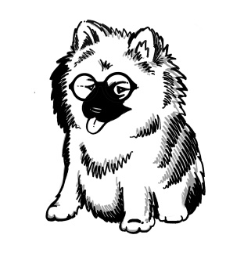

Keeshond Health DOES Matter

Last chance for subsidised Eye Testing

The Keeshond Club and the North of England Keeshond Club both recommend that all Keesies are eye tested at some point and we want to take a snapshot into the health of Keesie eyes to determine whether or not there are possible causes for concern or emerging conditions - such as Juvenile Cataracts or late onset PRA.

The first testing was held at the Keeshond Club’s Ch show in April, where 33 Keesies (including 7 oldies) were tested and all were clear; in total 37 Keesies hold a current clear eye certificate. The next testing session will be the North of England’s Ch show on Sunday 20th November 2022 at Thorpe Willoughby Village Hall YO8 9PA where Paul McPherson BVMS CertVOphthal MRCVS has agreed to do our testing.

All Keeshonds from bouncy puppies to Golden Oldies are encouraged to participate; it doesn’t matter if it’s a much-loved companion or a glamorous show dog. You are all welcome and don’t have to enter the show – just come along.

There are many types of eye disease, both congenital (conditions that exist from birth or soon after birth) and non-congenital (conditions that develop later in life), that affect dogs. Many of these conditions can have serious effects on health and welfare, causing pain, blindness, or the need for lifelong medication and should be taken into consideration when breeding dogs.

Older dogs eyes in particular should be examined regularly for a number of reasons: as several inherited eye problems may only be detected later in life, to identify age-related eye diseases and more importantly, to collect data which might either mitigate or identify problems which may arise in later life (longitudinal information).

The cost for Keeshonds will be just £25 per dog and £15 for a Golden Oldie (aged 8 & over) thanks to a generous subsidy from the Keeshond Health Matters Fund. Any other breed of dog may come for testing at a cost of £55 per dog – Gonioscopy will NOT be available. Please bring your dog’s KC registration with you. Standard BVA charges for a routine eye examination are: 1st dog £60; Group testing (25 or more) £50 and dogs over 8 years £38 – so you can see what a bargain offer this is!!

To have your dogs tested at this one off price please let me know so that we have an idea of numbers attending or for further information, contact Anji Marfleet - email: health@keeshondhealthmatters.co.uk. Further information can be found www.bva.co.uk

